Test Case: tc006_SPX_Dev5_Crear_Requisicion_Spot_Tipo_Cobro_Proyect_Urgent
Step 1 - Enter username and password and click to button Enter: Credentials Entered
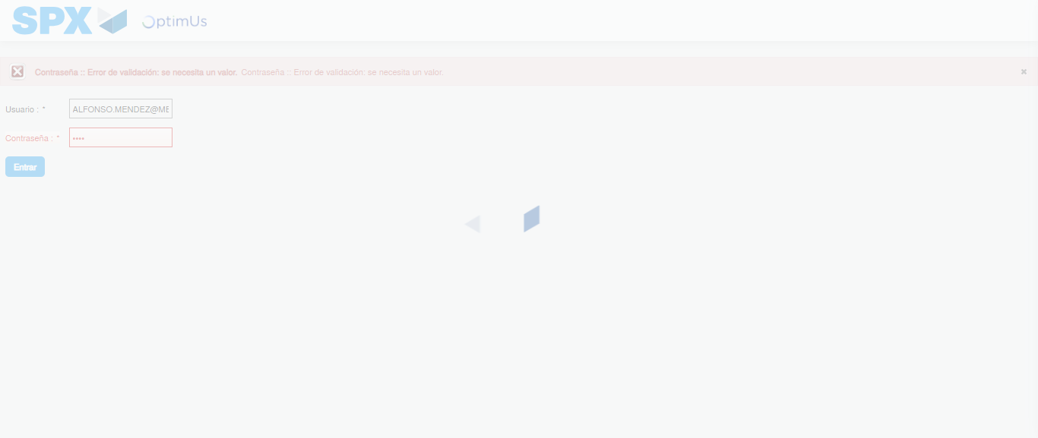Image file-name: QC_Testing-tc006_SPX_Dev5_Crear_Requisicion_Spot_Tipo_Cobro_Proyect_Urgent-1783379441205

Step 2 - Select to UEN and Access to Spot Buy Requisitions : UEN Correctly selected and Correct access
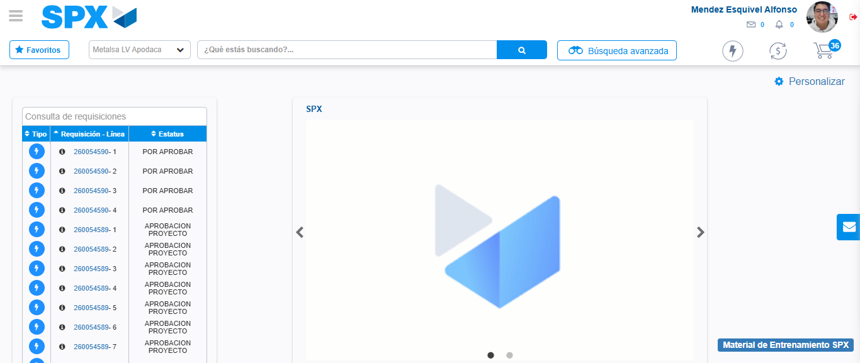Image file-name: QC_Testing-tc006_SPX_Dev5_Crear_Requisicion_Spot_Tipo_Cobro_Proyect_Urgent-1783379472717

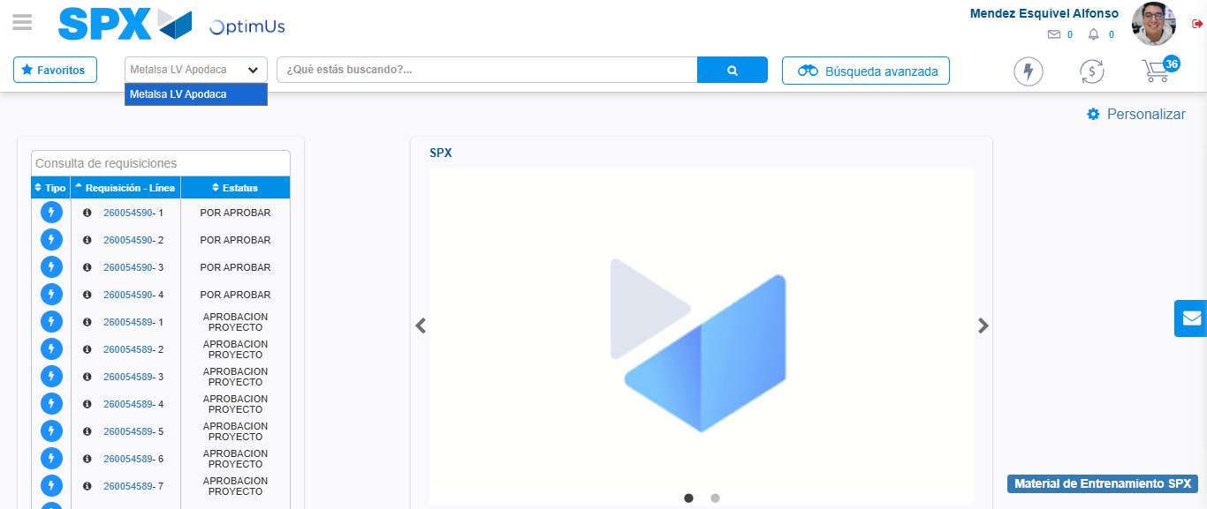Image file-name: QC_Testing-tc006_SPX_Dev5_Crear_Requisicion_Spot_Tipo_Cobro_Proyect_Urgent-1783379475164

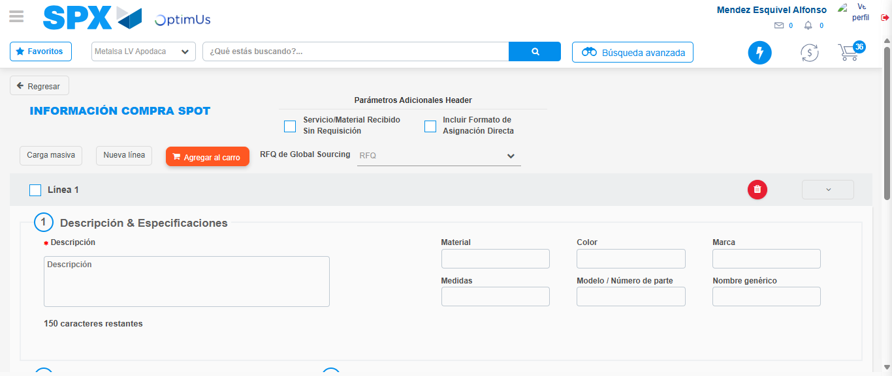Image file-name: QC_Testing-tc006_SPX_Dev5_Crear_Requisicion_Spot_Tipo_Cobro_Proyect_Urgent-1783379488458

Step 3 - Data Capture Spot Buy Requisition: Data captured correctly
Image file-name: QC_Testing-tc006_SPX_Dev5_Crear_Requisicion_Spot_Tipo_Cobro_Proyect_Urgent-1783379488711

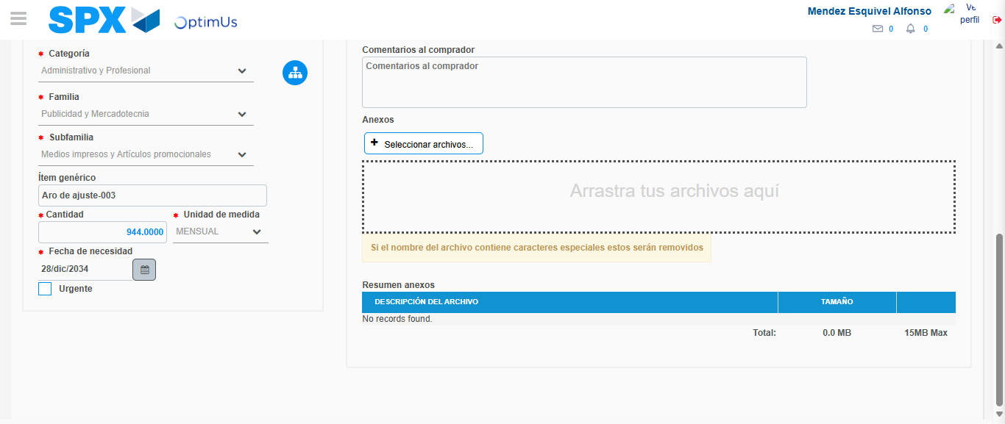Image file-name: QC_Testing-tc006_SPX_Dev5_Crear_Requisicion_Spot_Tipo_Cobro_Proyect_Urgent-1783379499348

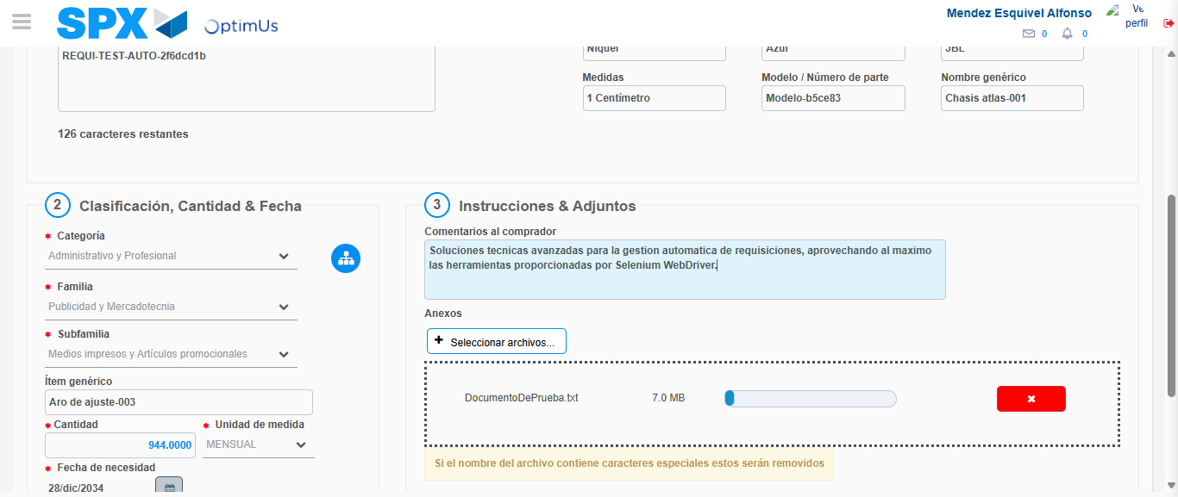Image file-name: QC_Testing-tc006_SPX_Dev5_Crear_Requisicion_Spot_Tipo_Cobro_Proyect_Urgent-1783379500078

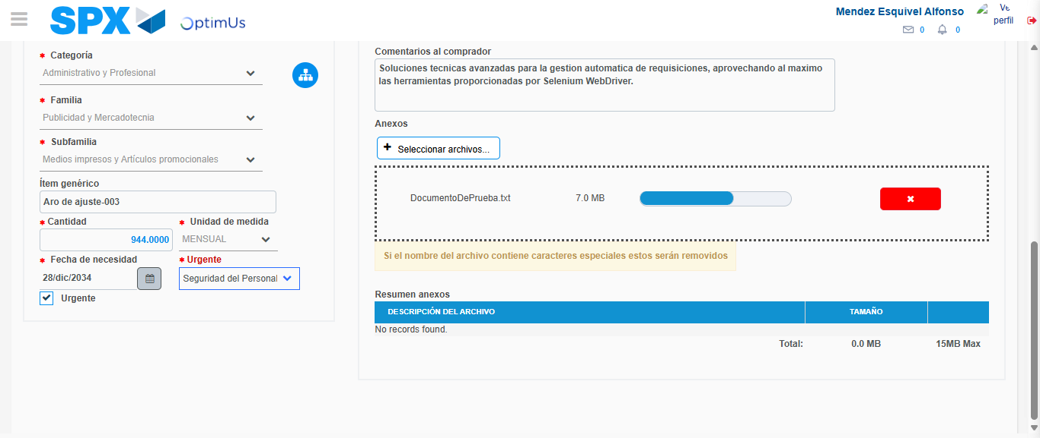Image file-name: QC_Testing-tc006_SPX_Dev5_Crear_Requisicion_Spot_Tipo_Cobro_Proyect_Urgent-1783379503661

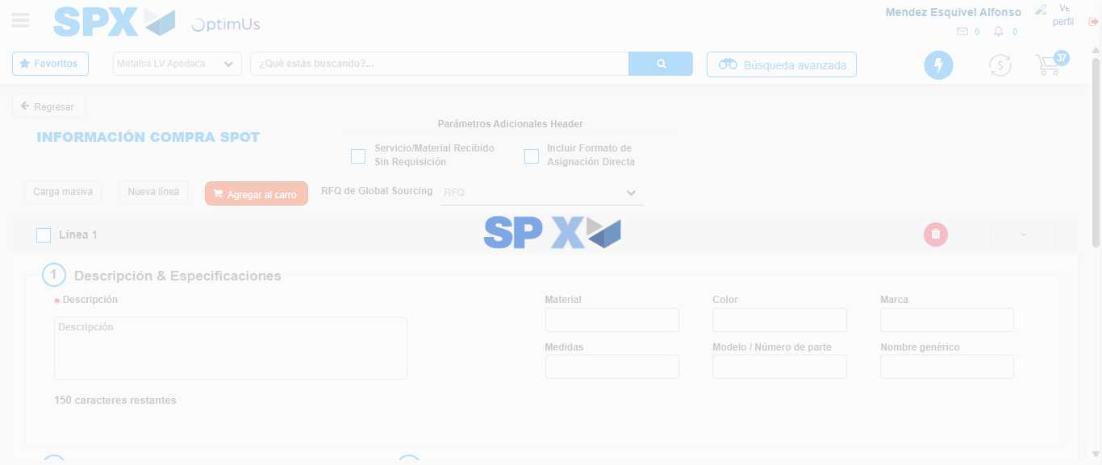Image file-name: QC_Testing-tc006_SPX_Dev5_Crear_Requisicion_Spot_Tipo_Cobro_Proyect_Urgent-1783379510614

Step 7 - Return to Main Page SPX : Return to Main Page SPX
Image file-name: QC_Testing-tc006_SPX_Dev5_Crear_Requisicion_Spot_Tipo_Cobro_Proyect_Urgent-1783379472717

Image file-name: QC_Testing-tc006_SPX_Dev5_Crear_Requisicion_Spot_Tipo_Cobro_Proyect_Urgent-1783379475164

Image file-name: QC_Testing-tc006_SPX_Dev5_Crear_Requisicion_Spot_Tipo_Cobro_Proyect_Urgent-1783379488458

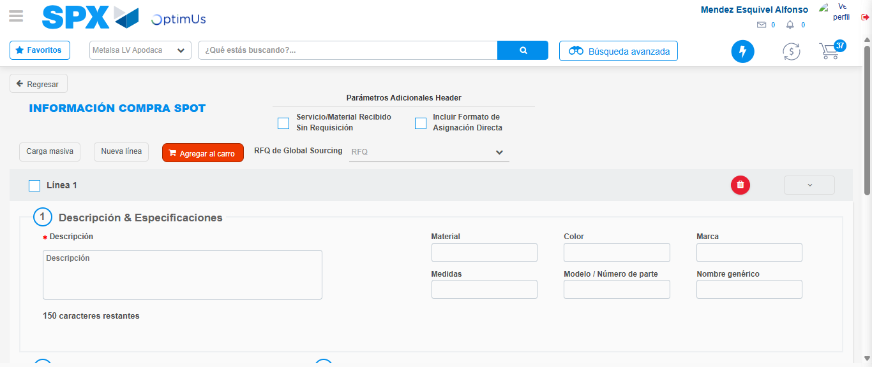Image file-name: QC_Testing-tc006_SPX_Dev5_Crear_Requisicion_Spot_Tipo_Cobro_Proyect_Urgent-1783379512844

Image file-name: QC_Testing-tc006_SPX_Dev5_Crear_Requisicion_Spot_Tipo_Cobro_Proyect_Urgent-1783379513032

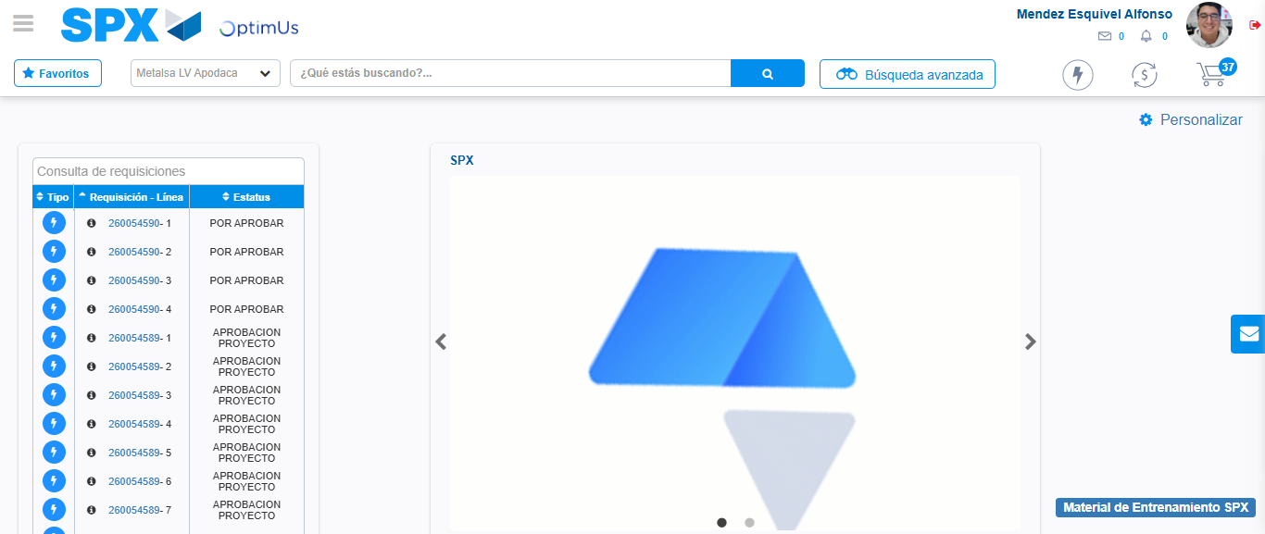Image file-name: QC_Testing-tc006_SPX_Dev5_Crear_Requisicion_Spot_Tipo_Cobro_Proyect_Urgent-1783379534018

Step 8 - Log Out : Log Out SPX
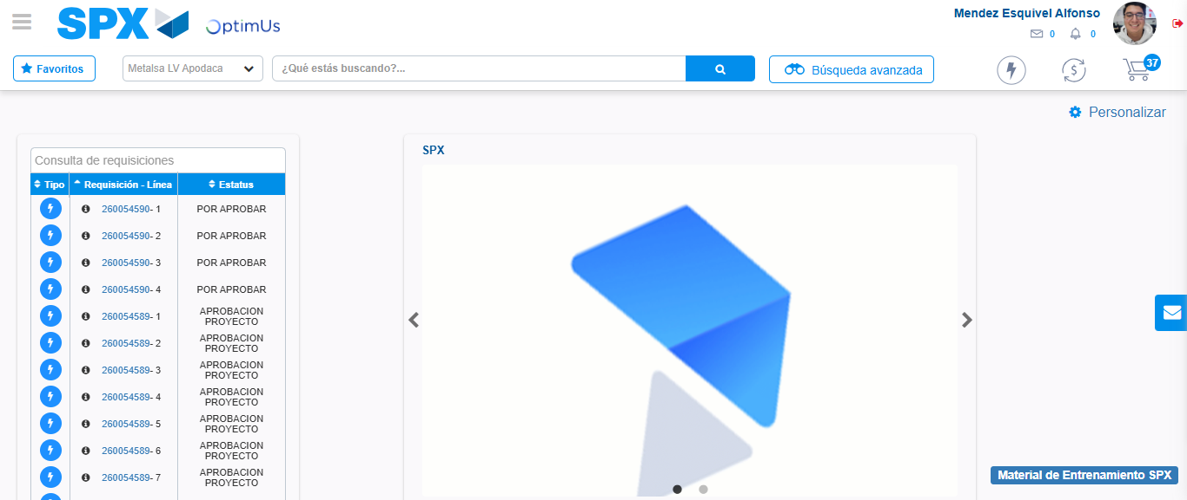Image file-name: QC_Testing-tc006_SPX_Dev5_Crear_Requisicion_Spot_Tipo_Cobro_Proyect_Urgent-1783379534258

